**“Eh, what’s up Doc?”**

Chanell Noise

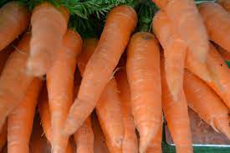

*In recent times, healthier snacks are holding their ground against more traditional, unhealthy snack foods.*

Carrot sales are booming. From major city to major city, more folks are buying more carrots. In 2020 carrots were the most popular snack purchase out of the nine snacks surveyed. Researchers looked at nine snacks: bananas, bran, chocolate chip cookies, oatmeal raisin cookies, potato chips, pretzels, whole wheat snacks, arrowroot and carrots.

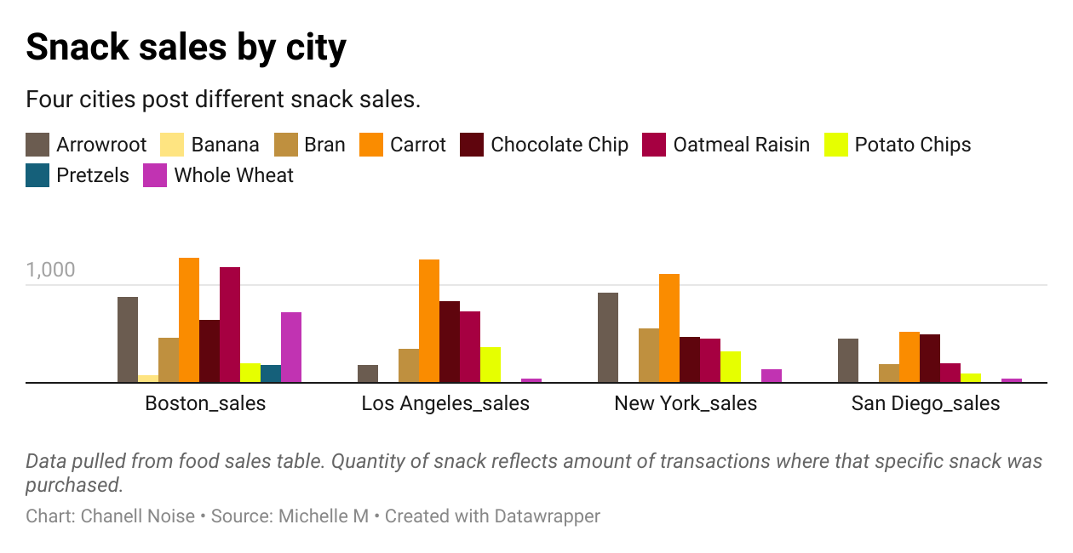

They compiled a data set that spanned four large cities. Two cities in the east (Boston and New York) and two cities in the west (Los Angeles and San Diego.) In Boston alone, 1281 transactions were for carrots! Compare that number to the 205 sales for chips and it’s no contest.

Go-to snacks tend to be sticky, salty and sweet- all the best tastes. Candy, popcorn, sodas and cookies are readily available at many public locations like movie theatres, theme parks and of course, grocery and convenience stores. For health advocates, these food sale numbers are comforting. If this data highlights a trend in America- there is a light at the end of the tunnel for healthy diets.

The top three grossing snacks across all cities in 2020 were carrots, oatmeal raisin cookies and arrowroot snacks. The lowest grossing snacks were bananas, pretzels and potato chips.

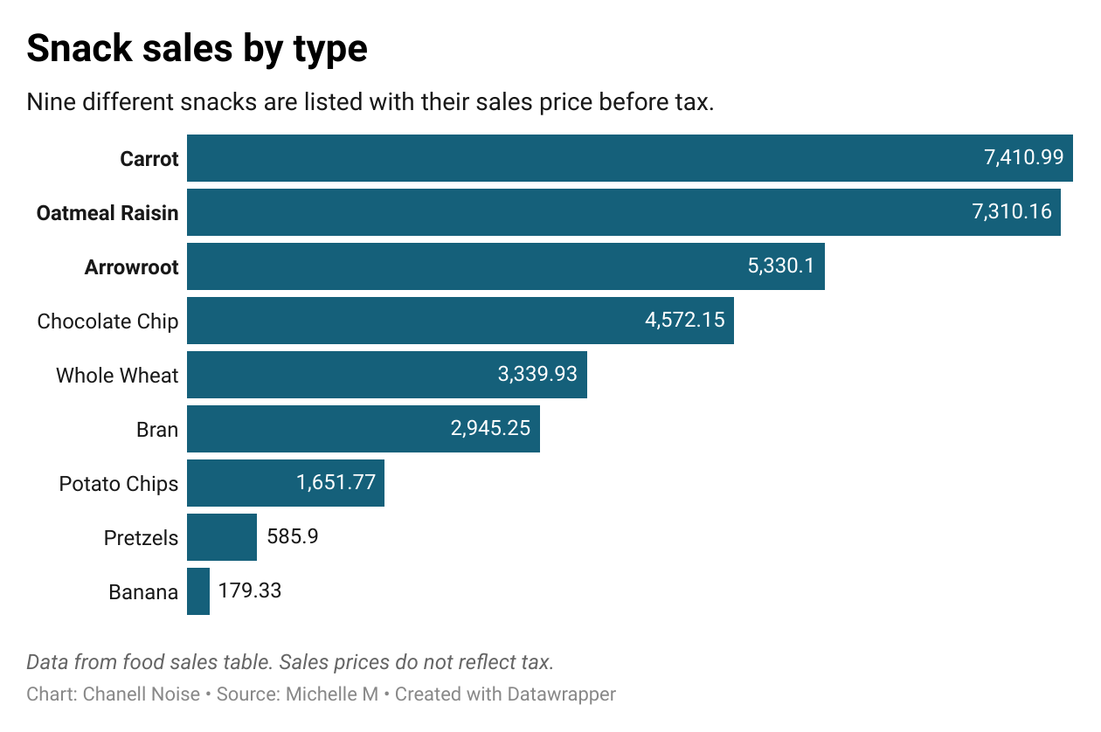

Health advocates, like dieticians and primary care doctors have warned against too much sugar or salt intake for years. Lots of either can cause heart, digestive, skin and weight problems.

It will be interesting to see how traditional giants like Frito-Lay (Cheetos) and PepsiCo (Lays) respond to these numbers. Potato chips across all four cities in 2020 only brought in $1651.77. Health-conscious chains, like Whole Foods, are positioned to become snack leaders. Mom’s, Yes Markets and Whole Foods carry items like arrowroot, organic carrots and whole wheat snacks in abundance.